**Report**

**Of**

**Requirements specification**

**Subject:**

**develop educational website**

**Prepared by:**

**Adem Abassi , Adem Bouadila &**

**Oussama Meddeb**

**College year 2023-2024**

1.Introduction:

1.1. Description:

"Learn Up" is an educational app within the online learning domain, designed to help students overcome time constraints and understand difficult subjects. It offers a user-friendly interface for searching courses, sharing materials, and engaging in discussions, with a tagging system for efficient navigation.

1.2. Objective:

This report presents the "Learn Up" project, an educational platform designed to help students overcome common challenges such as time constraints and difficulties understanding certain subjects. The application aims to be a supportive companion for those pressed for time or in need of additional clarity, especially as exams approach. With its user-friendly interface, the application offers a seamless experience, allowing users to easily search for specific courses, share study materials, and engage in discussions to deepen their understanding. The tagging system ensures efficient navigation, making it easy to locate relevant subjects, resumes, or inquiries.

2.Functional Requirements Specification:

2.1. Requirements:

The project aims to create a study website that meets the following needs:

- Registration

- Document management

- Voting

- Authentication

- Community chat

## 2.2. Actors Identification:

An actor is the role assumed by a user interacting with the developed system:

User: Any person accessing the LearnUp platform has the capability to browse courses, exams, and engage in chat. Additionally, users can add, download, vote on courses and exams, or participate in discussions with others.

The admin: This is the supervisor who possesses all control permissions to manage users and verify their courses and exams.

3.Non-Functional Requirements Specification:

Non-functional requirements are like quality checks for your app's features. They're super important because they impact how well the

app works for users, even though they're not about the specific things the app does. Here's what you need to think about:

- Reliability: The app should work smoothly without any hiccups, making sure users are happy with how it performs.

- Error Handling: If something isn't clear or goes wrong, the app should explain it clearly to users so they can understand and keep using it.

- User-Friendly Design: The app should be easy and pleasant to use, so users don't have to struggle with finding things or understanding what they see.

- Security: It's crucial to keep user’s personal info safe, so the app needs to be designed to protect their data.

- Maintenance and Reusability: Make sure the app is built in a way that makes it easy to update and use parts of it again in other projects.

4.Conception UML:

4.1User case diagram:

a global use diagram

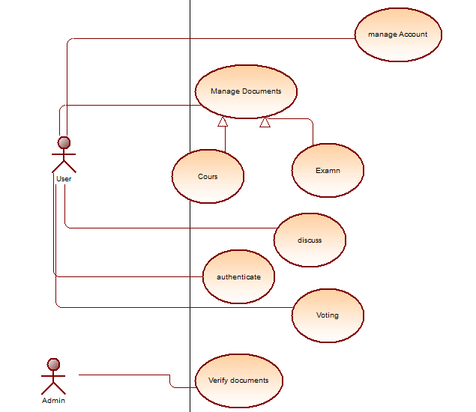

4.2Sequence diagram:

4.3Class diagram:

Global class diagam :

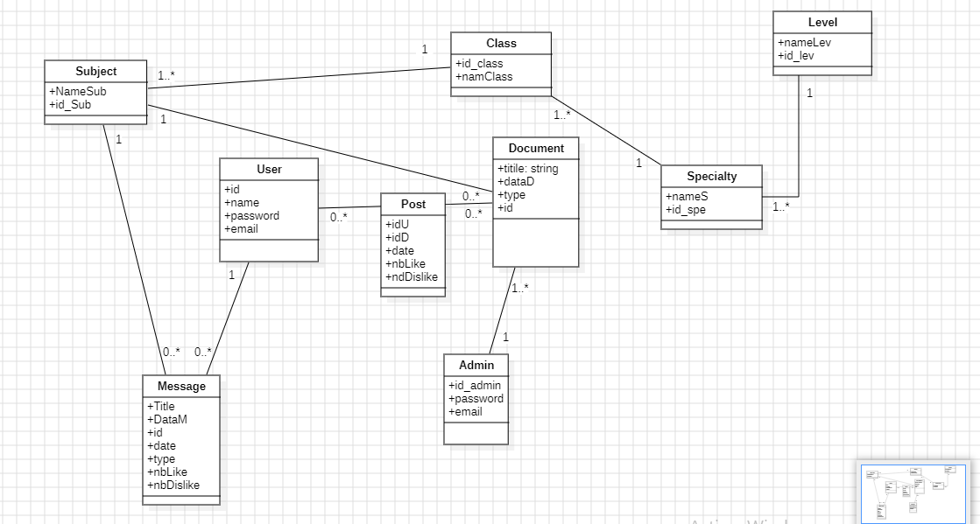

5.Conclusion:

In this chapter, we introduced our project “LearnUp” alongside of covering the importance of requirements specification for our software under the name of "LearnUp". We discussed identifying functional and non-functional requirements including reliability, error Handling, user-Friendly Design, security and maintenance and reusability, determining actors, and creating user case diagram in addition of sequence diagram and classes diagram.